RWE Analytics All tables in HBase

+----------------------------+

| name |

+----------------------------+

| biomarker_test |

| cohort |

| cohort_member |

| cost |

| diagnose |

| diagnose_attributes |

| effection_dict |

| lab_test |

| med_dosing_schedule |

| pathological_stage |

| patient |

| patient_event |

| patient_group |

| patient_group_info |

| patient_history |

| side_effection |

| stg_biomarker_test |

| stg_cost |

| stg_diagnose |

| stg_diagnose_attributes |

| stg_lab_test |

| stg_med_dosing_schedule |

| stg_pathological_stage |

| stg_patient |

| stg_patient_event |

| stg_side_effection |

| stg_surgery |

| stg_survey |

| stg_survival |

| stg_treatment |

| stg_treatment_journey_info |

| study |

| surgery |

| survey |

| survival |

| therapeutic_area |

| treatment |

| treatment_journey_info |

+----------------------------+

1. Biomarker_test

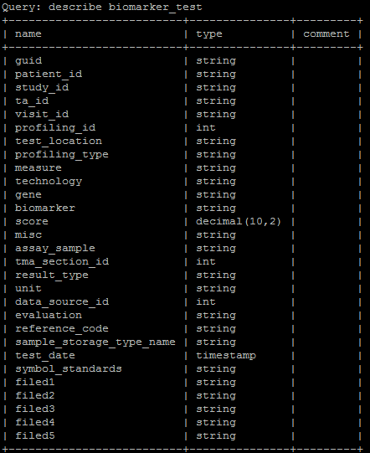

1. Cohort

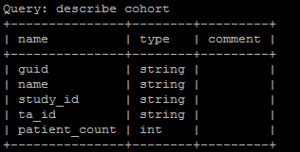

1. cohort_member

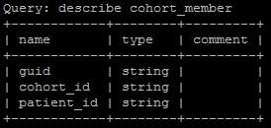

1. cost

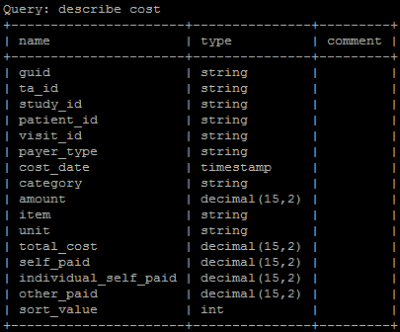

1. diagnose

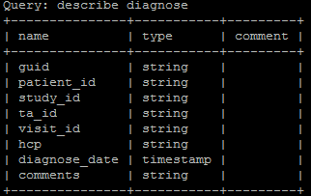

1. diagnose_attributes

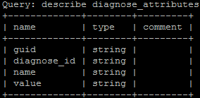

1. effection_dict

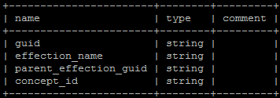

1. lab_test

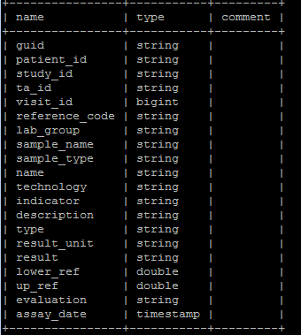

1. med_dosing_schedule

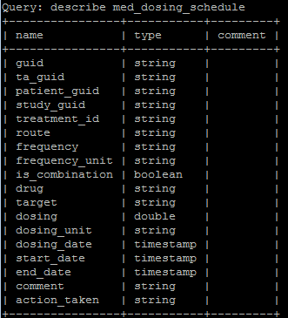

1. pathological_stage

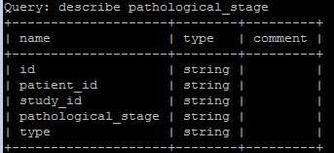

1. patient

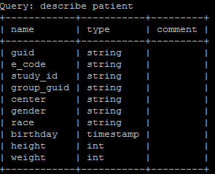

1. patient_event

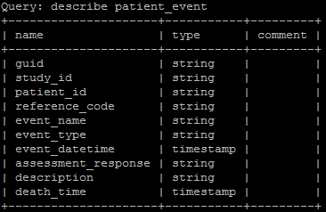

1. patient_group

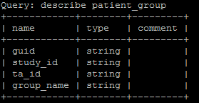

1. patient_group_info

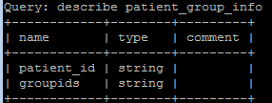

1. patient_history

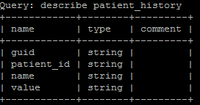

1. side_effection

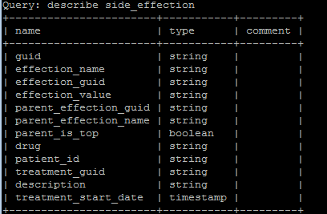

1. stg_biomarker_test

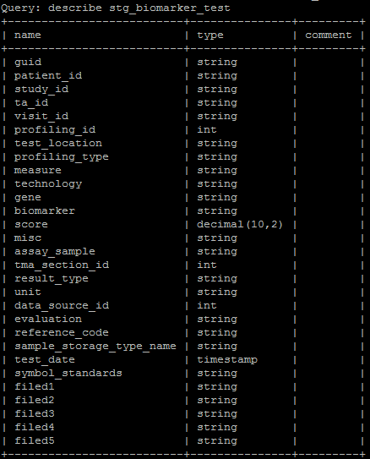

1. stg_cost

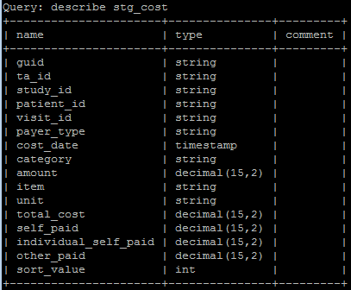

1. stg_diagnose

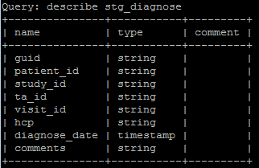

1. stg_diagnose_attributes

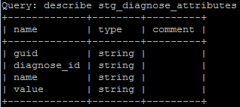

1. stg_lab_test

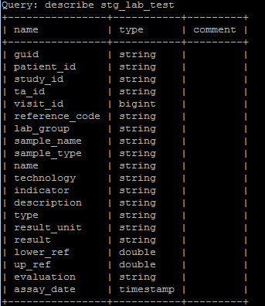

1. stg_med_dosing_schedule

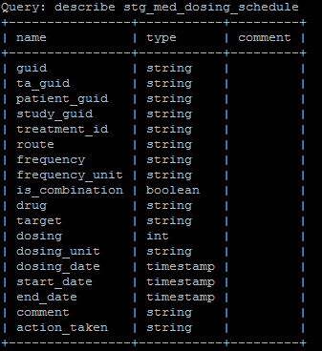

1. stg_pathological_stage

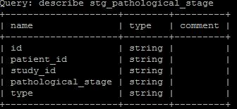

1. stg_patient

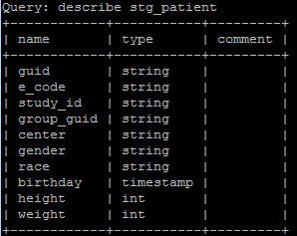

1. stg_patient_event

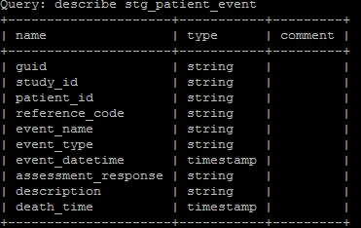

1. stg_side_effection

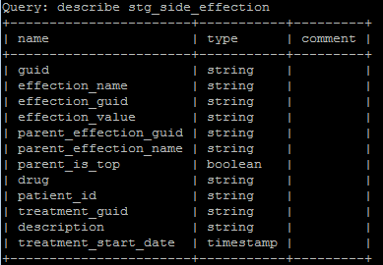

1. stg_surgery

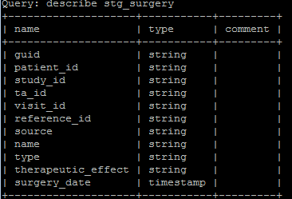

1. stg_survey

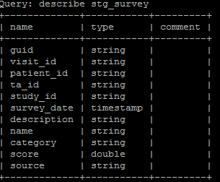

1. stg_survival

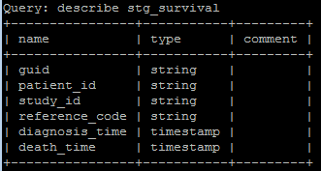

1. stg_treatment

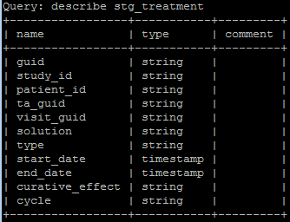

1. stg_treatment_journey_info

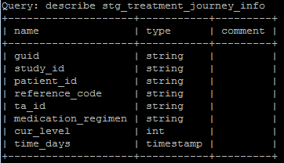

1. study

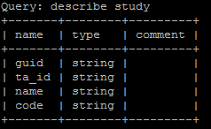

1. surgery

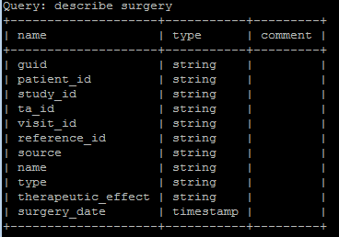

1. survey

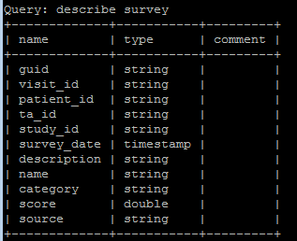

1. survival

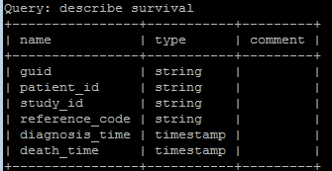

1. therapeutic_area

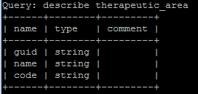

1. treatment

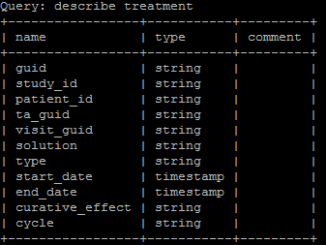

1. treatment_journey_info

